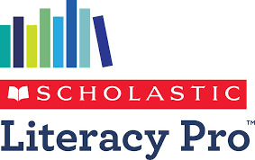
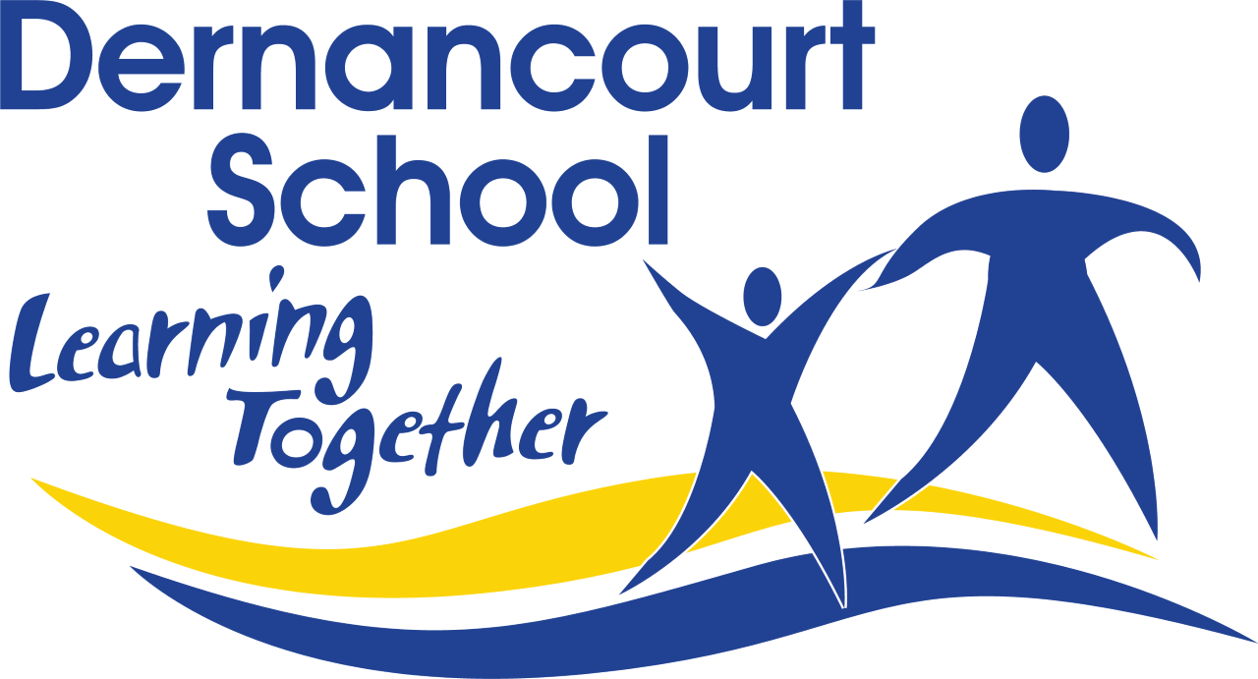
Term 1 2026
Dear Parent or Caregiver,
Your child is using Scholastic Literacy Pro in years 3-6 to support his/her independent reading.
One of the greatest gifts we can give children is to instil a love of reading. It is not enough to simply teach children to read. We need to provide them with a variety of literature that will make them wonder, make them laugh and take them to other worlds.
At school the students sit their Literacy Pro Test – this provides them with their Lexile level. The Lexile level helps them find the right books when browsing the library and choosing books they want to read.
The more books your child reads, the better they become at reading. When students complete a Literacy Pro book, they are encouraged to take a short 10-question quiz that measures their comprehension of the book they have read. We encourage students to read as many books as they like and take as many quizzes as they can at home and at school.
Once your child has a Lexile level and commences reading Lexiled books, they can access and complete online quizzes at home by following these steps:
1. www.scholasticlearningzone.com
2. Choose Australia
3. Org ID: D8R9
4. Enter student username and password
Username: first name followed by initial of surname then 001
e.g John Smith = johns001
Password: reading1
Literacy Pro is a great way for teachers and parents to monitor and motivate independent reading.
You can see their reading record, how many words they have read, and celebrate when they reach a certificate level for completing quizzes on the books they are reading.
Students can also access Literacy Pro eBooks via their normal LitPro account. After logging in they will see a button alongside the Literacy Pro button called “Literacy Pro Library”. Clicking on this will allow them to access the catalogue of eBooks and quizzes available.
If you would like to find out more about Literacy Pro and your child, please don’t hesitate to contact your child’s classroom teacher or myself.
Sue Thornton
Library Manager
Dernancourt School

