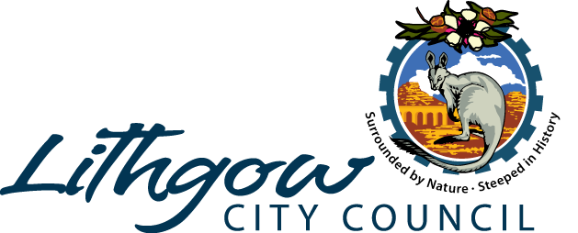
Media Release

5 September 2023
Halloween “Crafternoons”

Lithgow Library is excited to announce that in October the library will be getting into the spirit of Halloween by offering themed craft afternoons to celebrate Lithgow Halloween.

Come to the Library and create something truly terrifying and spooky!

Each week there will be a different craft and no two weeks will be the same. There will be a variety of different crafts to suit all ages you are welcome to take the craft home, or it can become part of the library display.

The dates and times for the SPOOKtacular events are as follows:
Thursday October 12th, 3.30-5pm.
Thursday October 19th, 3.30pm-5pm.
Thursday October 26th, 3.30pm-5pm.

All activities are FREE and no bookings are required.

Please contact the Lithgow Library on 63529100 for more information. Alternatively, you can pop into the Lithgow Library or head to the social media page for all up to date information on events through Facebook under, “Lithgow City Council Libraries”.

We hope to SCARE you all there….

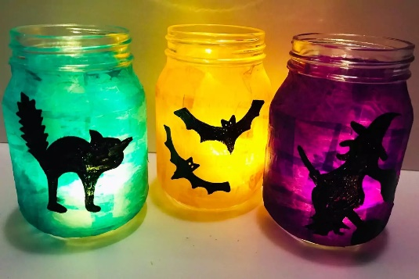
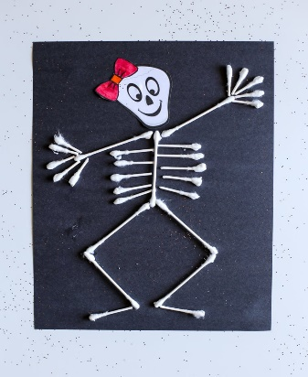 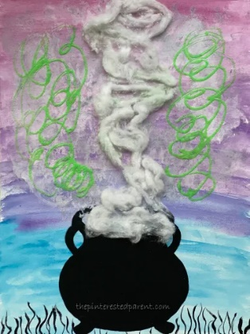
END
Contact| Sharon Lewis
Library Coordinator
Tel: 02 6352 9100

