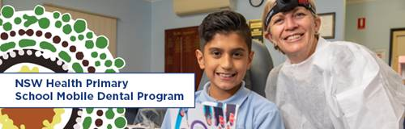

NSW Health Primary School Dental Program
NSW Health is working with public primary schools to offer free dental check-ups and preventive care to students as part of a school-based mobile dental program. Your child’s school has been selected to participate in this program.
The program involves a mobile dental team making scheduled visits to your child’s primary school. During the first appointment a dental check-up and preventive care package will be provided, subject to parental consent.
NSW Health prioritises the health, well-bring and safety of your staff and students. The program will utilise all available information provided by NSW Health, the Australian Government and the World Health Organisation (WHO) in relation to COVID-19. Our staff have implemented and reinforced a number of additional, proactive health and safety measures to ensure we can continue to provide your students with the best and safest experience possible. This will include NSW Health staff completing a temperature screen of your child prior to their dental examination.
The program is scheduled to visit your child’s school from [Select Date] to [Select Date].
Parent Information and Consent Packs will be sent home, including information sheets, consent forms and the program privacy statement. Parents/guardians who want their child to receive care are advised to:
- Read all the information provided
- Carefully complete the consent forms
- Return the consent forms to the school as soon as possible
More information about the program is available on the NSW Health website: https://ww.health.nsw.gov.au/oralhealth/primaryschooldental.

