Nhulunbuy Primary School Facebook Page   | Click on the link below to follow.  Facebook
Audiri App (Fortnightly newsletter, events calendar, student absences)   | Click on the link below to sign up.  Audiri App
Dojo (teacher / parent communication)   | Click on the link below to sign up.  ClassDojo for Teachers
NPS e-mail   | nps.frontoffice@education.nt.gov.au
NPS Website  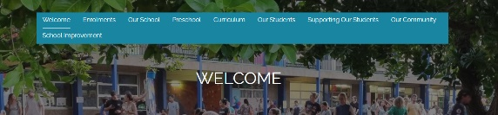 | Click on the link below.  nhulunbuyprimary.nt.edu.au
Teacher contacts | Staff e-mail address can be found at the bottom of each newsletter (posted on Audiri and website).

